**MUSIC PLAYER**

------------------------------------------------------------------------

# Table Of Contents

1. *Overall*
2. *Source Code Structure*
3. *How To Implement*
4. *Credits*

## A) Overall

This source code allows you to create music player app within minutes without requiring any coding skills. It has beautifully designed minimalist user interface. You can easy alter interface according to your taste.

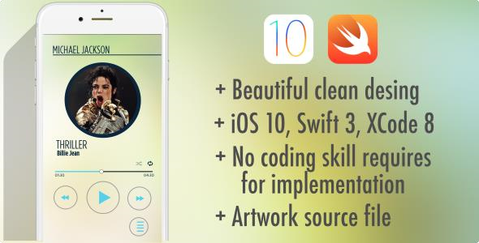

## B) Source code structure

This is a clean swift code and you can open with latest Xcode version . Main controller is

"ViewController.m" If you want to change anything in term of coding Either you need to edit PlayerViewController.m or storyboard files.

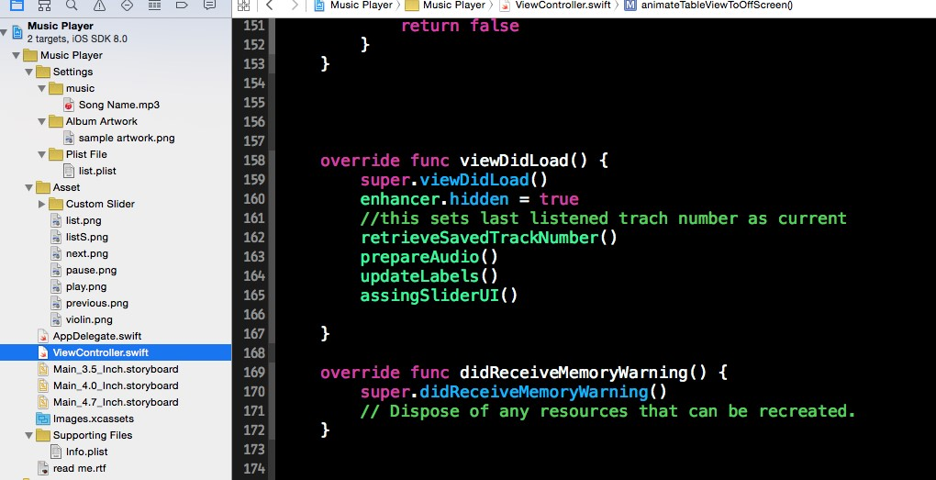

Storyboard Screenshot

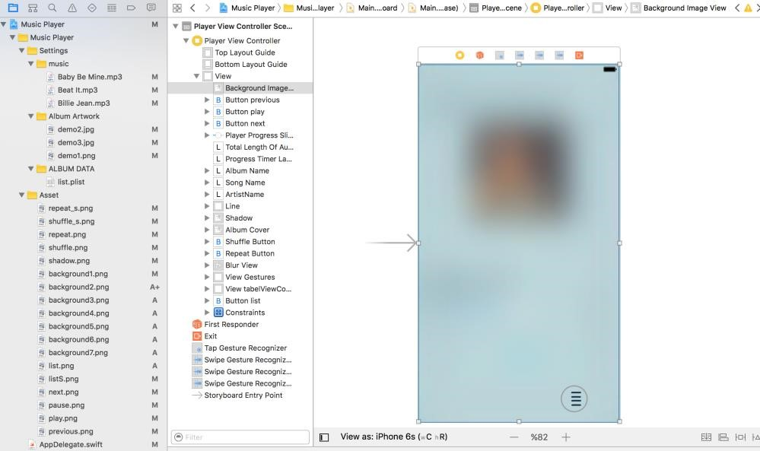

## D) How To Implement

All you need to do is fill "**list.plist**" following figure shows how to fill out .plist files.

Sample .plist file (Artist: Michael Jackson Album: Thriller )

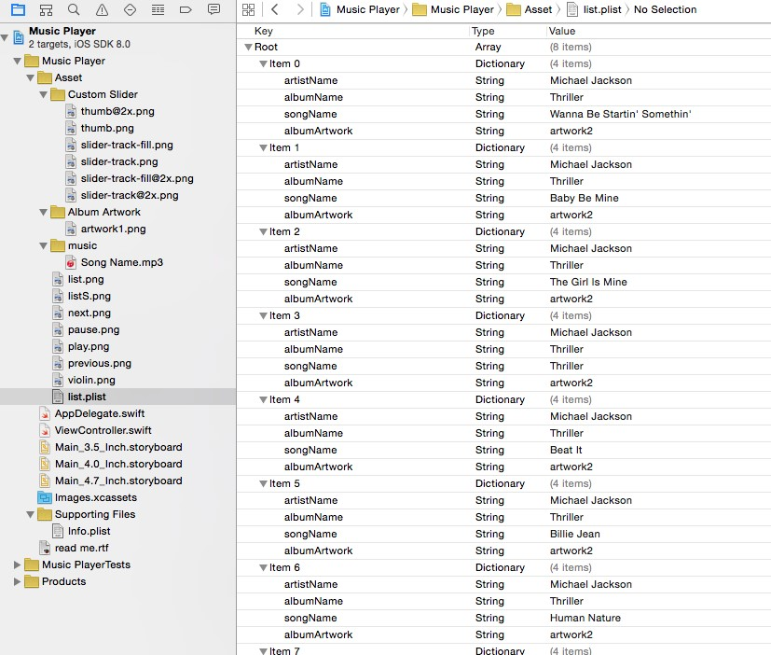

Once you finish filling out .plist file then import your songs into project. make sure you have exactly same name what you put on .plist file.



Then import album artwork again artwork name must be exact same what you entered into .plist file.



If you want to change background image. Go to PlayerViewController.Swift file and change "selectedBackground" constant.

//Choose background here. Between 1 – 7  **let selectedBackground = 1**

## D) Credits

I have used following sources in the code

• Sample music from zero-project.gr